**Vehicle Dummy Webpage & Selenium TestScript**

First of all, run Vehicle Dummy Webpage Project. Output of this project will appear like this.

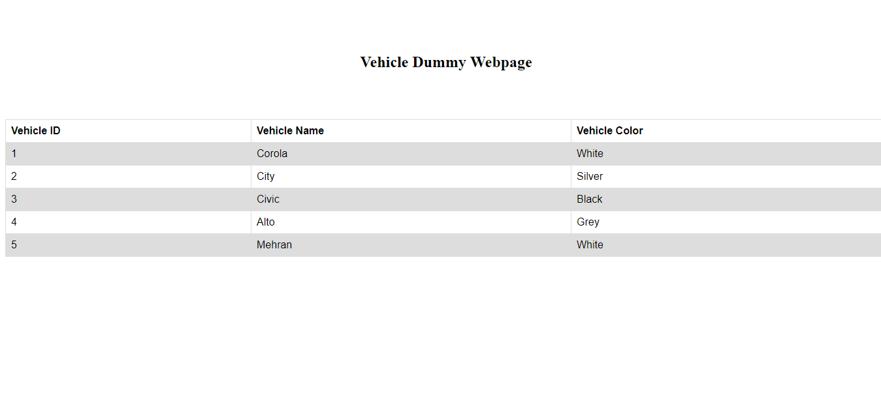

Secondly, run Selenium TestScript Project. It will initiate its own Chrome window and Vehicle Dummy Webpage get loaded. Output will appear like this.

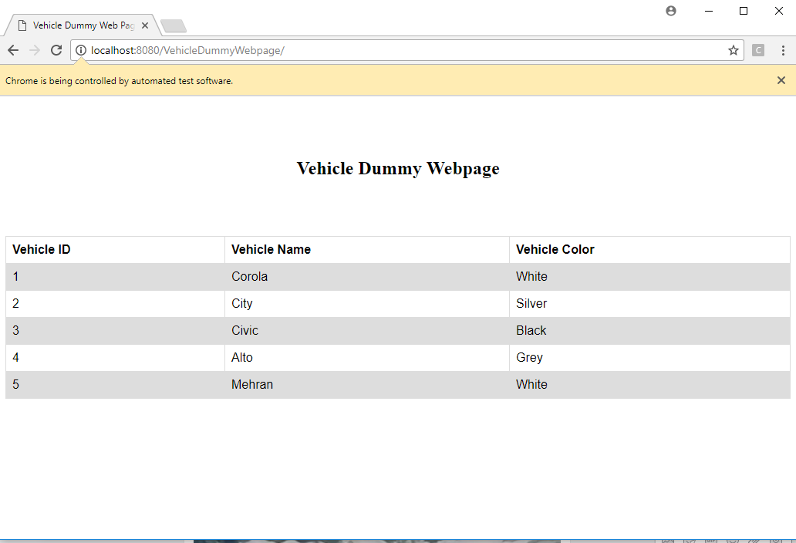

Thirdly, output on the console of Selenium TestScript Project will appear like this.

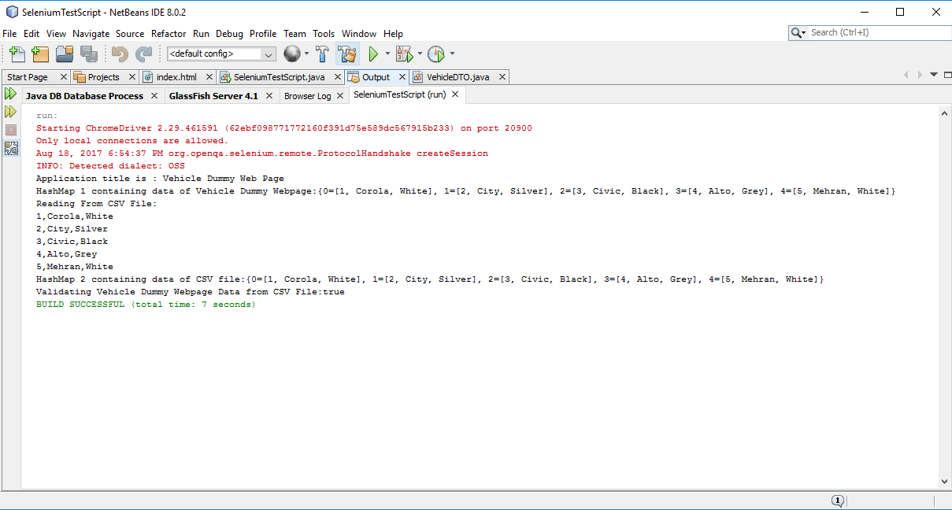

In the above output,

* First of all, it is displaying Hashmap1 containing data that is read from the Vehicle Dummy Webpage.
* Then, it is displaying data that is read from csv file named as “file.csv”.
* Then, it is displaying Hashmap2 of data that is read from csv file.
* And, in the last, it is comparing both Hashmaps i.e. Hashmap1 & Hashmap2. If data get matched, then it will display true else false.

**Note:**

* If you don’t run Vehicle Dummy Webpage Project before running Selenium TestScript Project, then it will display "Validating Vehicle Dummy Webpage Data from CSV File: False, no match Found" as data is not loaded in the Selenium Chrome Driver.
* But if run Vehicle Dummy Webpage Project before running Selenium TestScript Project, the it will display "Validating Vehicle Dummy Webpage Data from CSV File: True" – Required Output.